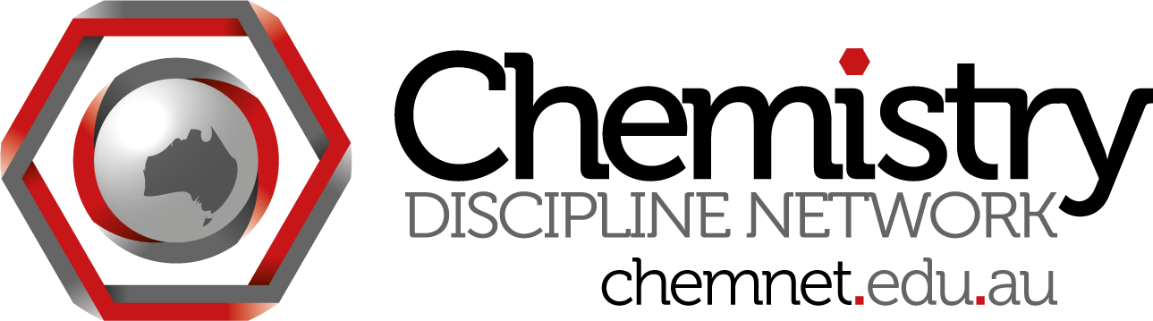
ChemNet skype meeting #20
Wednesday August 28 at 3:30 pm Brisbane time
Attendees:
Madeleine Schultz (QUT) madeleine.schultz
Dino Spagnoli (UWA)
Emma Bartle (UQ)
Siggi Schmid (Sydney)
Steph Beames (UTS)
Magda Wajrak (ECU)

Minutes:

- Catalyst grants
Emma Bartle - working with Nancy Longnecker and Mark Pegerim - developing communicative competence in chem ugrad. Students created 3 min podcast without chem communication. Compare with outcomes after course on communication. ca 120 podcasts in each course, groups of 3. Only 5% but high quality podcasts.
Intro chem, students not interested - how to get them excited? Some were very engaged.
Working on coding rubric based on literature. Using $ to fund a RA who has graduated from MScComm, chemist by background. To be done in Nov.
- ACSME preparation - discipline day
Who is coming? If Simon Pyke not there no point having a TLO meeting.
What TLO will be discussed?
General concerns of chem ed community...

- TLO meeting July 9 - lab work was not talked about much, mostly on assessment. Tick off TLOs throughout year, still have standard end of year exam that gives them their mark. SS thought that meeting TLOs would end up in mark, or that we would have less emphasis on exams - lab tasks, posters etc during the year. TLO meeting is yes or no so how to translate into mark?
Currently a student with 50% will pass. The idea is that must first meet TLO to pass.
Very difficult to draw lines. Problem is that nothing might change.
At QUT some things have changed with academics being aware of TLOs and which of their assessment items should cover which TLOs.
Need to find out what the RACI process will be - Mark Buntine?

Next meeting: ??? Will there be a next meeting? Catalyst grants, what else to discuss post ACSME

