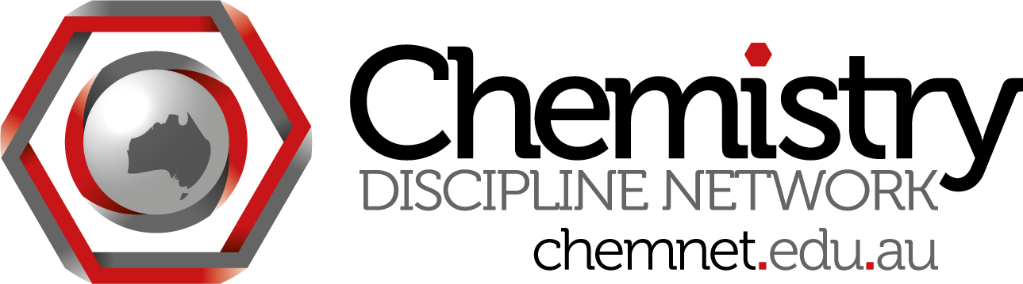
ChemNet skype meeting #16
Wednesday April 24 at 3:30 pm Brisbane time
Attendees:
Madeleine Schultz (QUT) madeleine.schultz
Steph Beames (UTS)
Dino Spagnoli (UWA)
Mark Williams (UWS)
Siggi Schmid (Sydney)

Minutes:
- ACSME meeting in Sept; Chemistry Network Meeting 1 - 3:30 pm Sept 19 UCan.
Dino - Current reseatch ties in to learners journey theme of conference. Goal is to see how students no chem background view their chemistry studies, how it ties in with their uni pathway
Can our Discipline Day meeting go longer? Steph to talk to Luby
Abstracts due June 7; can either do a poster or talk. Submit an abstract even if not sure.
ChemNet paying 2 registrations for the people using forums to discuss your research

2. Catalyst grants
Deadline May 17. Will pass them around to a committee and rank them. Better to have a few larger chunks of money than lots of tiny bits.
Upper limit around $1000, maybe more as we have James' salary back.

3. ACDS meeting 18/19 July is Sydney
Glennys should attend, might be an opportunity for f2f discussion of discipline day work.

4. UWA postgrad teaching internship
For PhD student, along with PhD they get paid, do some lecturing, also do a little research project. Dino offered to supervise some of these around first year teaching. Ways to enhance learning experience.
Other institutions offering this?
Mark Williams has tried to encourage something like this at UWS but with no luck.
Sydney has teaching tutors with scholarship, no lecturing.

5. James
Originally hired for 2 years, leaving 6 months early. Do we need a new person for the last few months? What would they do?

Next meeting: Wednesday 29 May 3:30 eastern time

